INFLATION

The article contains the basic concepts for inflation as well as the inflationary trends during the last two years.

**Consumer price index (CPI)**

AEcO BUSINESS SOLUTIONS

**1. What is Inflation and CPI?**

**Inflation means the continuous increase in the general level of prices. Currency devaluation when less products are bought with a certain amount of currency than before the devaluation.**

**So, inflation from a general point of view is simply a "superproduction" of money, which on the one hand, obviously increases the prices of goods and on the other hand reduces the purchasing power of money. In this sense, as the inflationary period will we define those periods of time when the level of consumer prices – measured by the change in a consumer price index – generally increases.**

**Consumer price index or CPI for short - measures the change in the price level of goods and services used by household economic units for personal consumption (usually among the largest groups that are included in a CPI basket are food items, clothing, purchase and maintenance of houses, fuel, transport and medical care). The index is calculated using the structure of final consumption of household economic units. The index is used as the official measure of inflation in Albania.**

**Each of the mentioned groups of personal consumption has a weight in the basket, in practice the determination of the weights is based on the economic importance of each group, which is calculated against the total.**

**More specifically, if consumers devote only 20 percent of their budget to clothing expenses, then the weight that this group will occupy in the basket will be 20 percent.**

**As noted, it is the consumers who, with the way they spend, determine the "face" of inflation. It is for this reason that the indices in different countries have common points, which mostly have to do with the presence of the same groups of goods as well as with the similarity of the weights that these groups occupy to the total. These similarities become more apparent if economies with similar structures and levels of development are compared.**

AEcO BUSINESS SOLUTIONS

**INFLATION: HOW IS IT CAUSED?**

**Inflation is a monetary phenomenon, while central banks have the exclusive right to issue money in a real environment. So, the central bank, with its policy, is one of the main causes of inflation. Especially nowadays, central banks are increasingly considered responsible for controlling inflation and therefore, the number of central banks that only care about the stability of consumer prices is ever increasing. More and more, the idea that price stability is the best contributor to the realization of other objectives related to economic growth, employment, etc. is prevailing. So, by generalizing we can reach the conclusion that the monetary policy with its ability or inability, can control, i.e. slow down or accelerate the growth of the level of economic prices .**

**Inflation appears with different levels of impact, however, researchers, especially when it comes to distinguishing it quantitatively, have managed to identify four types of inflation: low inflation (deflation), moderate inflation, galloping inflation and hyperinflation. low inflation means a positive inflation rate, which fluctuates in the range of 0 - 4 percent on an annual basis. in some cases, especially when, after relatively long periods of low inflation, a constant acceleration of inflation is observed, which takes it one level higher, it can be said that the alarm bells have started ringing. Inflation is called galloping when prices on an annual basis increase by a percentage of two or three digits. In economic environments where prices double or triple in the span of a year, problems abound and the life of individuals, firms, and economic agents in general, becomes very difficult. This inflation is accompanied by the breakdown of macroeconomic stability, leading to the decline of production, the deterioration of the currency position, the destruction of savings, the dollarization of the economy, and many other negative phenomena. While the economy can survive a galloping inflation, there is no doubt that hyperinflation is a real challenge for it.**

AEcO BUSINESS SOLUTIONS

**What is at stake is the central bank's ability to control the money supply. By means of the instruments at its disposal, it can withdraw or inject money into the economy in accordance with the requirements that the economy may have. In a market economy this is done simply, it is enough to remember the other ability of the central bank to manipulate the price of money - the interest rate. By increasing the interest rate, monetary policy aims to increase the price of credit, which will lead to a decrease in demand. Thus, the money that is not required as a loan will remain in the coffers of the central bank. The opposite action means a decision by the central bank to increase the amount of money that will be injected into the economy, and as a consequence inflationary expectations should increase in the economy.**

**Unlike many other countries, in Albania, the Government can borrow directly from the central bank, that is, it finances the budget deficit with new money cuts, thus increasing inflationary pressures in the economy. So, the way the government finances the budget deficit can itself be a possible source of inflation, especially when the budget deficit is consistently high and this deficit is not sold to the public, but is covered by printing. new money. There is more than enough evidence that in all cases of hyperinflation, its main causes have been large budget deficits and their financing through money printing. As we saw above, inflation in some cases may be the result of an expansionary monetary policy and in some other cases, especially in developing economies, inflation may simply result from the government's arbitrariness to finance the budget deficit with new money printing.**

AEcO BUSINESS SOLUTIONS

**Price indices in Albania in May 2023 and May 2024.**

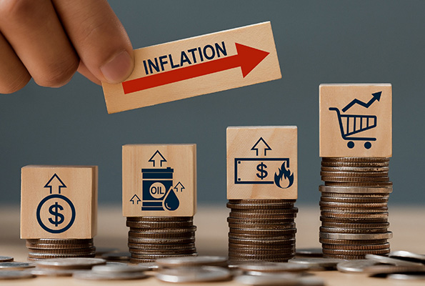

**The Consumer Price Index in May 2023 reached 114.3 compared to December 2020.**

**The annual change of the consumer price index in May 2023 is 4.7%, a year ago (2022) this change was 6.7%.**

**The monthly change of the consumer price index in May 2023, compared to April 2023, is -0.3%.**

**The Consumer Price Index in May 2024 reached 116.8 compared to December 2020. The annual change of the Consumer Price Index in May 2024 is 2.2%, a year ago this change was 4.7%. The monthly change of the consumer price index in May 2024, compared to April 2024, is - 0.2%.**

*\* All statistical data obtained from INSTAT*

**Annual CPI Change**

**• May 2023: 4.7%**

**• May 2024: 2.2%**

**The annual change in consumer prices has dropped significantly from 4.7% in May 2023 to 2.2% in May 2024. This shows that inflation has slowed down significantly this year.**

**Monthly CPI change**

**• May 2023: -0.3% (compared to April 2023)**

**• May 2024: -0.2% (compared to April 2024)**

**The monthly change shows a slight decrease in prices in both months, but the decrease is slightly smaller in May 2024 (-0.2%) compared to May 2023 (-0.3%).**

AEcO BUSINESS SOLUTIONS

**Annual Inflation**

**Annual inflation has fallen from 4.7% to 2.2%, suggesting a stabilization of consumer prices and better control over inflation in 2024. This is a positive sign for the economy, as lower inflation means greater stability of prices and may be the result of successful monetary and fiscal policies.**

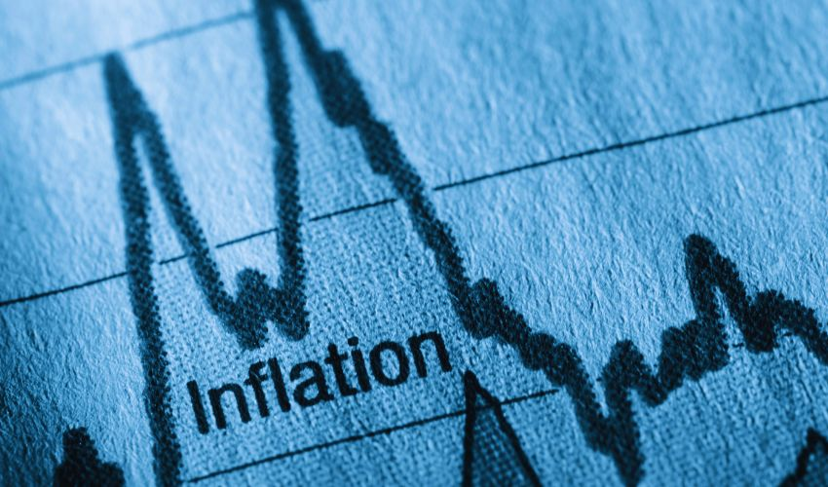

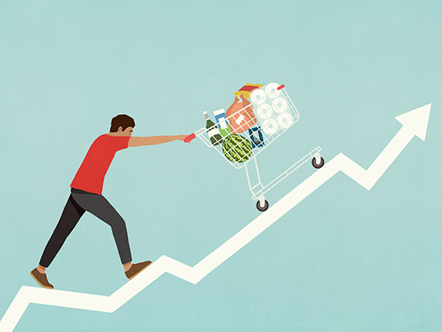

**Monthly Change**

**The monthly change in the index has been negative in both periods, but less negative in May 2024. This shows that, although prices have decreased on a monthly basis, the decline has become less pronounced. A negative monthly change in the index suggests a period of deflation or a stabilization of prices.**

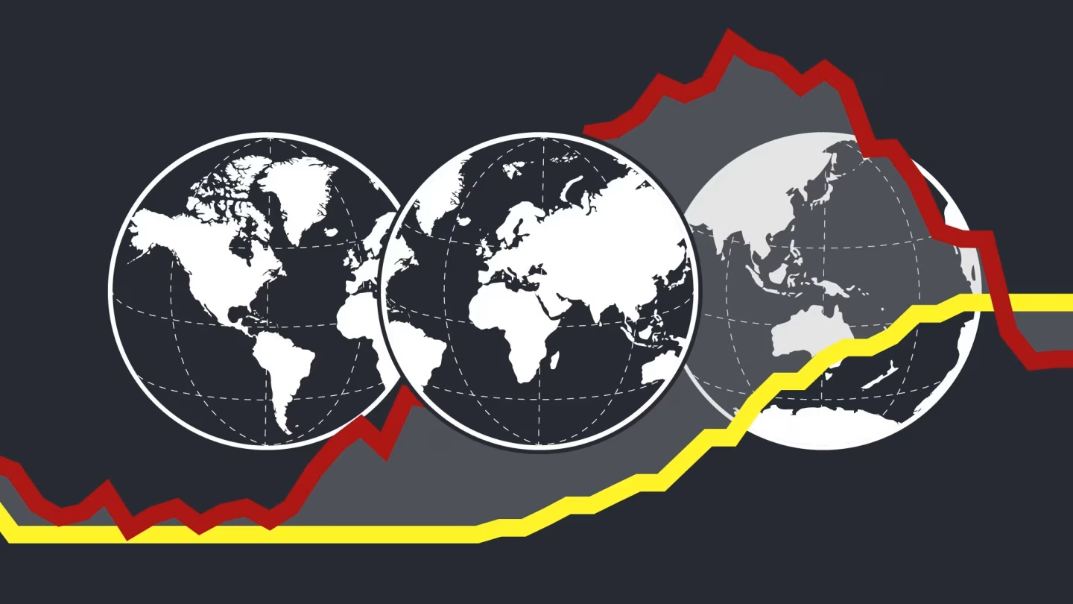

*\* All statistical data obtained from INSTAT*

**In summary, the data show a continued increase in the consumer price index, a slowdown in annual inflation and a downward trend in monthly prices. This is a positive indicator for economic stability, although continued monitoring is needed to ensure that this trend continues.**

*\*All statistical data obtained from INSTAT*

Inflation (Annual changes in the consumer price index) from the period March 2022-March 2023 to May 2023-May 2024.